e-mova: Ukrainian 10 Online

Cultural Enrichment Part A: Ukrainian Dance and Regions of Ukraine – Level 1

Ukrainian dance is a very popular cultural activity for hundreds of children and young adults living in rural and urban centres on the Canadian prairies. The music, costumes and corresponding intricate movements are high-spirited, colourful and entertaining. Many will agree that nothing draws out a crowd of young people at a Ukrainian folk festival or wedding like the ever-popular circle dance known as the kolomeyka.

Ukrainian folk dance was first introduced to this continent by Vasyl’ Avramenko, who is often called the “Father of Ukrainian Dance” in North America. Through Avramenko, a national form of dance from the Central Region of Ukraine, Poltava, emerged, with the corresponding Poltavski folk dance costumes reflecting the name of the region. This central regional style of dance and its colourful costumes became widely-recognized at community concerts and events in Western Canada. As a result, the folk dance known as the hopak from Central region became a signature dance representing Ukrainian-Canadian culture.

Another form of Ukrainian dance which quickly gained popularity originated in the Karpaty, or Carpathian mountain area of Western Ukraine known as Hutsul’shchyna. The inhabitants of this area, called Hutsuls, lived in remote villages which were untainted by urban trends toward modernization. The Hutsuls were able to preserve their folk traditions, complete with colourful costumes and lively dances, as a reflection of their simple, rustic lifestyle. Dancing from the Carpathian mountain region became known as Hutsul folk dance with corresponding regional Hutsul’ski costumes.

Post World War II immigration to Canada from several regions of Western Ukraine resulted in a new wave of interest in costumes, folk dance, music and traditions from these regions. Dances from Bukovyna (the area in front of the Carpathian mountains) and Zakarpattya (the area behind the Carpathian mountains, also known as Transcarpathia) began to appear in the repertoire of many dance troupes. The Bukovyns’ki and Zakarpats’ki costumes and dance styles differed from the well-known Poltavs’ki and Hutsul’ski styles, and this difference became very appealing to audiences of all ages. Very soon a widespread movement to explore other regional dance styles became popular among many dance ensembles.

By the late 1970’s and 1980’s, Ukrainian dance on the prairies evolved into a well-developed expression of Ukrainian cultural identity, complete with elaborate concert productions, tours, workshops and competitions. Ukrainian dance instructors were in short supply for rural communities, where a kind of “cultural rebirth” had taken place through the art of Ukrainian dance. Soon dance instructors and choreographers from Ukraine were invited to give workshops or to stay in Canada as artistic directors of Ukrainian dance ensembles. The addition of new resource personnel added yet another dimension to the art form of Ukrainian dance in Canada.

This cultural enrichment unit will introduce you to vocabulary which is commonly used in relation to Ukrainian dance in Canada. The unit focuses on the map of Ukraine and the regions from which the most popular dance forms originated. The vocabulary lists present terms which will expand your knowledge of regions of Ukraine and your ability to speak about regional dances and costumes which are popular in Canada.

Additional Information

For more information about the early beginnings of Ukrainian dance in North America under the leadership of Vasyl’ Avramenko, consult the following websites:

http://en.wikipedia.org/wiki/Vasyl_Avramenko

http://en.wikipedia.org/wiki/Ukrainian_dance#Development_in_North_America

The website below offers interesting information about Ukrainian dance costumes in relation to regions of Ukraine:

http://www.zorya.ca/Regions_Costumes.htm

The website below contains an interactive map of the 25 regions of Ukraine.

http://www.infoukes.com/ukremb/mappuzzle.html

The web address below offers in-depth information about regions of Ukraine through a photo collage:

http://www.infoukes.com/ukremb/slideshow/slide-reg.htm

Websites which offer links to Ukrainian dance troupes around the world are listed below.

http://members.optushome.com.au/demyan/links.html

http://www.abuda.ca/webresources/

The websites given above illustrate the popularity of Ukrainian dance as an art form in many countries of the world where Ukrainian communities are found. Did you know that there are Ukrainian communities in so many countries of the world? This will be the topic of your next Cultural Enrichment segment, titled Ukrainians in the World.

Now you may view the PPT presentation of Ukrainian Dance and Regions of Ukraine - Level 1. Study the words and repeat the phrases several times so that you are familiar with the terms.

Ukrainian Dance and Regions of Ukraine: Level 1
Enrichment Package for e-mova: Ukrainian 10 Online

ТАНЦІ ТА РЕГІОНИ УКРАЇНИ:
РІВЕНЬ 1

МОВНІ ВПРАВИ

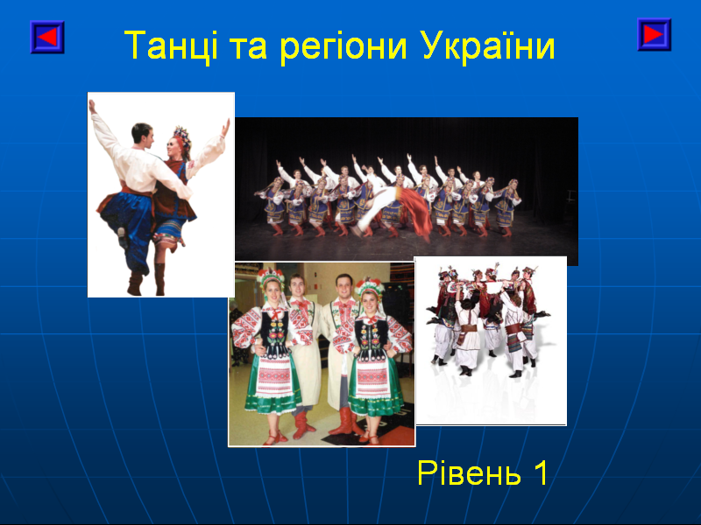

Dictionary Grammatical exercises

Словничок Граматичні
стор. 4-6 вправи
стор. 7-12
When you have completed this package, send in to your instructor by FAX.

Словничок
You have been introduced to some of these terms in the introduction to this segment. You are encouraged to view the PPT presentation and practise the audio clips in order to learn the new vocabulary. You will notice that many of the terms given below are cognates, or words which are similar to their English counterparts.

Іменники – Nouns
Буковина Bukovyna
гори mountains
гуцул Hutsul
Гуцульщина Hutsul’shchyna
Закарпаття Zakarpattya (Transcarpathia)
Карпати Carpathian Mountains
костюм costume
Полтавщина Poltavshchyna
регіон region
танці dancing (collective form) or dances (plural)
українці Ukrainians

Прикметники – Adjectives*
буковинський, -a, -e, -i Bukovynian
гуцульський, -a, -e, -i Hutsul
закарпатський, -a, -e, -i Transcarpathian
західній, -я, -є, -i western, from the west
полтавський, -a, -e, -i Poltavsky
центральний, -a, -e, -i central, from the central area

*Adjectives are words which describe nouns. In Ukrainian, adjectives take the gender of the noun which they are describing. More information about adjectives will be presented in this package.

Дієслова - Verbs
називатися to be called, to be named

In Canadian Ukrainian communities, you will often hear the question “Як ти називаєшся?” when someone would like to know your name. Literally, this means “How are you named?”. The phrase “Як тебе звуть?” or “How do (they) call you?” is more commonly used in Ukraine.

Graphic Organizer – A Visual Representation of Important Vocabulary

ГРАФІЧНА СХЕМА СЛОВНИЧКА
називатися
Полтавщина
полтавський
полтавська
полтавське
полтавські

гори Карпати

українець
українка
українці
регіон
регіони
костюм
костюми
танці

центральний
центральна
центральне
центральні

західній
західня
західнє
західні
західні

Буковина
буковинський
буковинська
буковинськe
буковинські

Гуцульщина
гуцул
гуцульський
гуцульська
гуцульське
гуцульські
Закарпаття
закарпатський
закарпатська
закарпатськe
закарпатські

Why Are Certain Words Grouped Together?

Words in the visual representation above are grouped together according to a particular feature or similarity. If you are a visual learner, these groupings (sometimes called ‘mind maps’) may help you to remember new words presented in the enrichment segment. In the chart above, groupings have been created according to grammatical features (verbs), themes (i.e. geography) or a similar root word. The center circle is a ‘catch all’ for vocabulary which doesn’t match other groupings.

Graphic organizers are ways to view similarities ‘at a glance’ in order to remember vocabulary more easily. If you find these graphic organizers helpful, you may want to create your own word groupings for other parts of this online course.

A Note About Adjectives
Masculine adjectives end in ий or ій
Feminine adjectives end in а or я
Neuter adjectives end in е or є
Plural adjectives end in і or ї

А. НАГОЛОСИ

This segment focuses on наголоси, which are accents marks placed on stressed syllables. Place accents on the appropriate syllables in the sentences below. In order to complete this assignment, listen carefully to the audio segments of the PPT presentation of
Ukrainian Dance and Regions of Ukraine - Level 1 and you will hear which syllables are stressed.

1. Це – Україна.

2. Ось тут – центральна Україна. Один регіон називається

Полтавщина.

3. Регіон – Полтавщина, а костюм – полтавський.

4. Це – Буковина.

5. Українці з Буковини мають буковинські костюми.

6. Це – гори Карпати. Тут живуть гуцули.

7. Регіон – Гуцульщина, а костюм – гуцульський.

8. Регіон за Карпатами називається Закарпаття.

9. Регіон – Закарпаття, а костюм – закарпатський.

10. Буковина, Гуцульщина й Закарпаття – в західній Україні, а

Полтавщина – в центральній Україні.

Б. ТЕКСТ

Add the missing words from the PPT presentation. Try to complete the exercise without looking back. Then check your work to see how many words you remembered correctly.

1. Це – Україна.

2. Ось тут – центральна Україна. Один регіон називається

____________________.

3. Регіон – Полтавщина, а костюм – ____________________.

4. Це – Буковина.

5. Українці з Буковини мають ____________________ костюми.

6. Це – гори Карпати. Тут живуть ____________________.

7. Регіон – Гуцульщина, а костюм – ____________________.

8. Регіон за Карпатами називається ____________________.

9. Регіон – Закарпаття, а костюм – ____________________.

10. Буковина, Гуцульщина й Закарпаття – в ____________________

Україні,а Полтавщина – в ____________________ Україні.

В. ГРАМАТИКА

1. Іменники (Nouns) – Прикметники (Adjectives)

A list of nouns is presented on the right. Adjectives which contain the root of the nouns appear in the list on the left. Match the nouns and adjectives which have a similar ‘root’, as shown in the example.

полтавський Закарпаття

буковинський захід

гуцульський Україна

закарпатський Канада

західній Буковина

український Полтава

центральний гуцул

канадський центр

2. Circle the Ukrainian cognates (words which remind you of familiar English words).

бейсбол
регіон журнал костюм учитель
Карпати Калґарі жінка хлопець гуцул

3. Він – Вона – Вони
How well can you distinguish between masculine, feminine and plural nouns?
Separate the nouns given below into the appropriate categories. Hint: “a” usually
indicates the feminine gender, “i” usually indicates the plural form.

українці, гуцул, буковинка, гуцули, українка, канадець, буковинці, гуцулка,
українець, канадка, буковинець, канадці.

він | вона | вони  українці

4. Дієслово - мати

Complete the exercise below with proper forms of the verb мати (to have). Note two new words related to Ukrainian dance: чоботи (boots), коралі (‘coral’ beads)

я маю ми маємо
ти маєш ви маєте
він має вони мають
(вона, воно)

1. Хлопець ____________________ чоботи.

2. Чи ти ____________________ костюм?

3. Діти ____________________ чоботи.

4. Ми ____________________ коралі.

5. Вона ____________________ костюм.

6. Чи ви ____________________ коралі?

5. Прикметники (Adjectives)

Write the appropriate adjective, using the noun which it describes as your guide.

український українська українське українські
( він ) ( вона ) ( воно ) ( вони )

1. Оксана має ____________________ костюм.
полтавський

2. Тут маємо ____________________ танці.
український

3. Гуцули мають ____________________ костюм.
гуцульський

4. Ми читаємо про ____________________ танці .
закарпатський

5. Полтавщина - це ____________________ регіон.
центральний

6. Хлопці мають квитки на ________________ концерт.
український

6. Answer the following questions using the locative case.

- Де вони живуть? ( Україна )
Вони живуть в Україні.

1. Де ви живете? ( Саскачеван )

2. Де живуть гуцули? ( Гуцульщина )

3. Де живуть канадці? ( Канада )

4. Де живуть українці? ( Україна )

5. Де живуть буковинці? ( Буковина )

7. Complete the chart with the missing adjectives.

буковинський
буковинська | закарпатська
буковинське
буковинські |  | гуцульські

центральний
українська
західнє

Г. ПИТАННЯ - QUESTIONS

Answer the following questions in full sentences. You will need to recall the phrase Як ти називаєшся? (How are you called?) which was explained earlier in this segment. The verb називатися (to be called or named) is declined as follows:

я називаюся ми називаємося
ти називаєшся ви називаєтеся
він називається вони називаються
(вона, воно)

1. Як називається місто в Канаді?

2. Як називається регіон в центральній Україні?

3. Як називаються українці в Гуцульщині?

- Як називається баба?

- Як ти називаєшся?

- Як називаються мама й тато?

- Як називається учитель/учителька?

- Як називається місто в Альберті?

Д. ДОСЛІДНИЦЬКИЙ ПРОЄКТ – RESEARCH PROJECT

Research the regional costumes of Ukraine. Include information about colors, styles, embroidery and fabric. Present your findings by preparing a short presentation in PowerPoint* form on this topic.

*If you are not familiar with PowerPoint, please ask your instructor to help you. If you prefer to submit a 1 page written summary of the topic in English, this is also acceptable.

Value of this Cultural Enrichment Segment: 5% of your total mark

